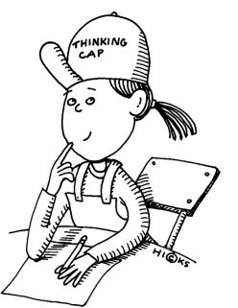

The Best Way to Memorize

Memorize actively, not passively.

Researchers have found that the worst way to memorize -- the way that takes the most time and results in the least retention -- is to simply read something over and over again.

If that is the way you memorize, forget it.

Instead, use as many of your senses as possible.
- Try to visualize in concrete terms, to get a picture in your head.
- In addition to sight use sound: Say the words out loud and listen to yourself saying them.
- Use association: Relate the fact to be learned to something personally significant or find a logical tie-in.

Examples:
- When memorizing dates, relate them to important events, the dates of which you already know.
- Use mnemonics: For example, the phrase "Every good boy does fine,” is used for remembering the names of the musical notes on the lines of the treble clef.
- Use acronyms, like OK4R, which is the key to remembering the steps in a reading method that is widely used.

Use this key to remember!

